Formatting

- Use only one of the following fonts:
- Arial sized 10
- Calibri sized 11
- Times New Roman sized 12

- Use justify alignment
Home ribbon tab, Paragraph chunk, Justify command button
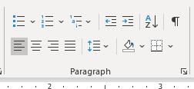

- Use 1.5 line spacing


- Consider using Heading 1 and Heading 2 styles
Home ribbon tab, Styles Chunk, Heading 1 (for main heading), Heading 2 (for subheading)
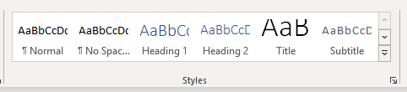

- Consider using automated table of contents
Perform step 4
On the page for your Table of Contents: References ribbon tab, Table of Contents chunk, Table of Contents command button
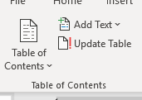

- Consider using automated references list
References ribbon tab, Citations & Bibliography chunk
- Styles: APA (to ensure you are using APA Referencing Style)
- Manage Source (to add sources of reference)
- Insert Citation (to add citation; you may choose to type instead)
- Bibliography (to add the list of reference)
Note: Citations and References must be crossed-referenced
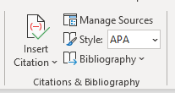

- Use automated page numbering
Insert ribbon tab, Header & Footer chunk, Page Number command button
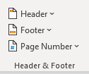

- Consider using automated captions for both tables and figures (diagrams and pictures).
Note: Captions for tables are located on top of the tables while captions for figures goes at the bottom.
References ribbon tab, Captions chunk, Insert Caption button
- Label: Table (used for table)
- Label: Figure (used for pictures and diagrams)
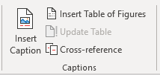

- Include abstract: one paragraph length that summarizes the content of your assignment

- Avoid using first person narrative (I, we, etc…) and second person narrative (you, etc…).

You may only use third person narrative (he/she, it, they, etc…).

Tips to avoid the two narratives:
- If you must refer to yourselves as a group, call yourselves the group, the students, the researchers, etc…
- If you must refer to yourself for the individual assignment, call yourself as he/she, the author, the student, the researcher, etc…
- If you must want engagement from the readers, address them as the readers, the audience, they etc…
- Or: Ultimately change the way to write the sentence. Instead of using subjective sentences, use objective sentences.
  - Example: When you click the button, something will happen.
  - Using subjective sentence: When the user clicks the button, something will happen.
  - Using objective sentence: Something will happen when the button is clicked.

- Avoid using contraction (combining two words into one).
Examples:
Yes | No
I am | I’m
is not | isn’t
will not | won’t

- Spell out single digits that are not part of a title, numbering, date, and time.

